Question 1

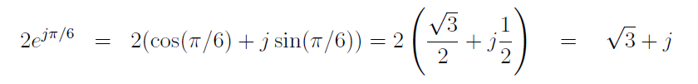

Question 2

Question 3

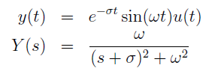

Question 4

Question 5

Question 6

